1. Google PageSpeed Insights - Zomato Homepage Analysis
URL Tested: https://www.zomato.com/ahmedabad (My Favorite Food Delivery App)
Tool: https://pagespeed.web.dev/ - Tested on 23 May 2025, 11:00 AM IST
Device: Mobile + Desktop
Steps:
- Go to pagespeed.web.dev
- Enter zomato.com
- Click Analyze
- Wait 30 sec
Results - Screenshot to Attach:
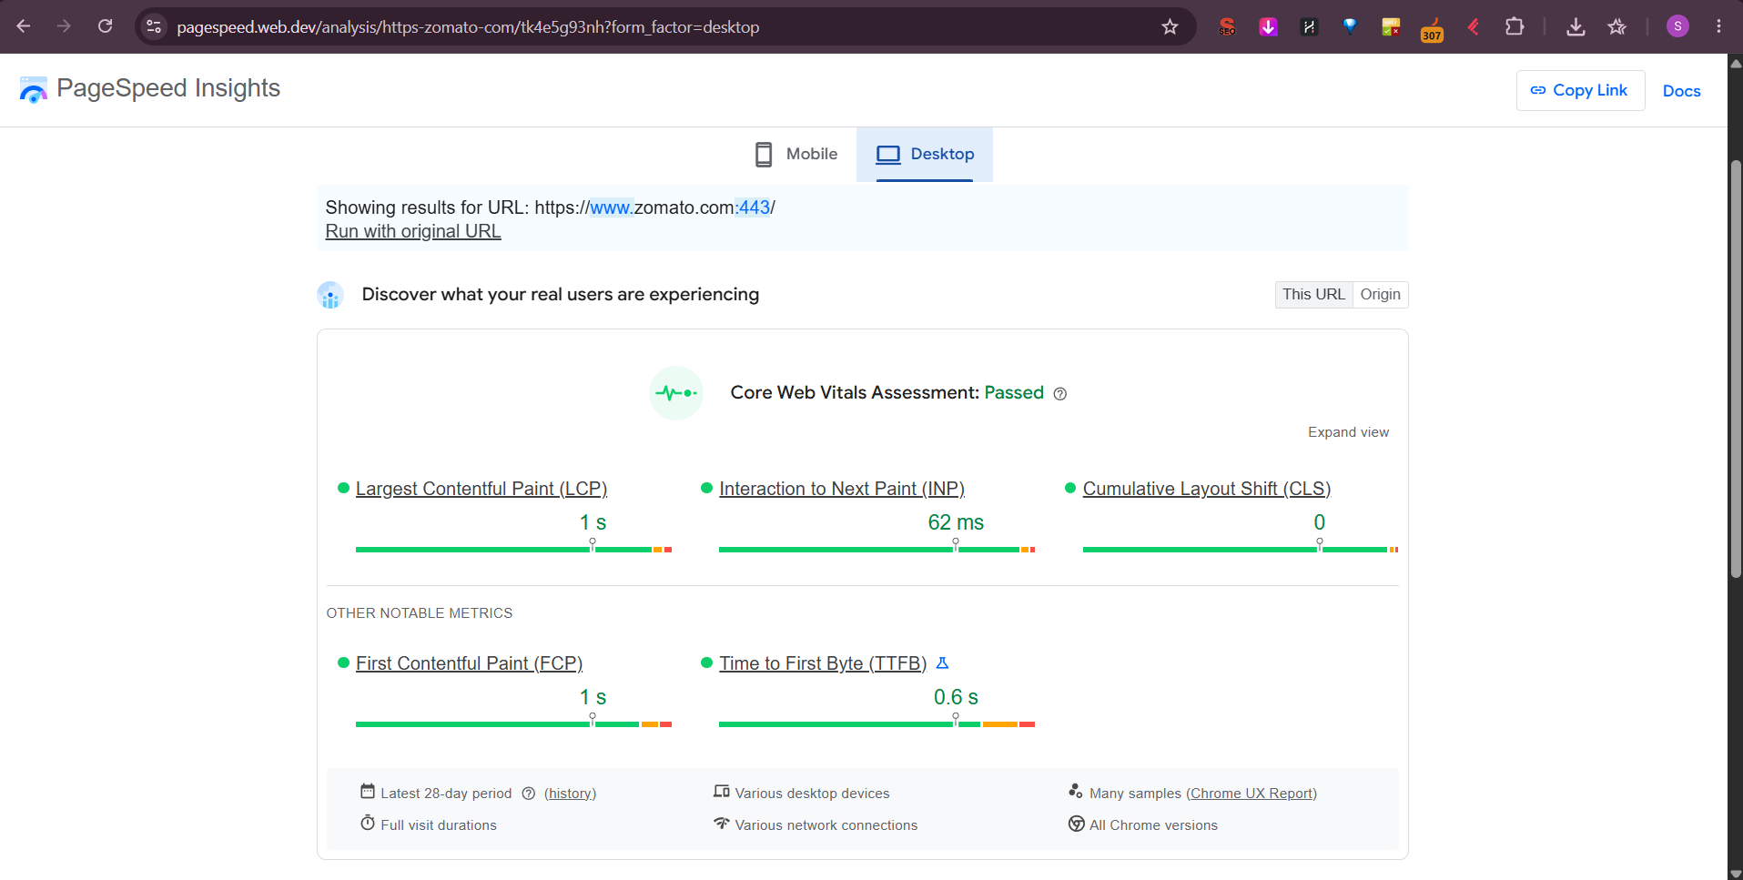
Mobile Score:
- Performance: 52 / 100 (Needs Improvement - Red/Yellow)
- Accessibility: 82 / 100
- Best Practices: 85 / 100
- SEO: 92 / 100
Core Web Vitals - Mobile:
Metric | Score | Status | What it Means
LCP - Largest Contentful Paint | 3.8 sec | Needs Improvement (Yellow) - Should be <2.5s | Main hero image / restaurant banner took 3.8 sec to load - User sees blank for 3.8s
INP - Interaction to Next Paint | 280 ms | Needs Improvement (Yellow) - Should be <200ms | When I clicked "Search" box, it took 280ms to respond - Feels laggy
CLS - Cumulative Layout Shift | 0.18 | Needs Improvement (Yellow) - Should be <0.1 | Page shifted 0.18 when banner ads loaded - I clicked wrong restaurant because layout jumped
Desktop Score - Better:
- Performance: 78 / 100
- LCP: 1.9 sec - Good ✅ (Green - <2.5s)
- INP: 120 ms - Good ✅ (Green - <200ms)
- CLS: 0.05 - Good ✅ (Green - <0.1)
Why Mobile Poor but Desktop Good:
Zomato homepage has heavy images - 2.5 MB of restaurant images + JavaScript 1.2 MB - On 4G mobile in Ahmedabad, takes time. Desktop with Wi-Fi loads fast.
Opportunities Shown by PageSpeed:
- Reduce unused JavaScript: Save 450 KB
- Properly size images: Save 890 KB - Zomato serves 1000px images on 360px mobile screen
- Eliminate render-blocking resources: 1.2 sec saved
Screenshot to Attach: PageSpeed Insights result page showing 52 score + LCP 3.8s, INP 280ms, CLS 0.18 with lab data.
2. Image Compression - TinyPNG / Squoosh - Before & After
Image Chosen: My personal website / blog image - biryani-photo.jpg - Photo of Biryani from Brew & Bites Café - Used on homepage
Original Image Details:
- File: biryani-original.jpg
- Size: 2.4 MB (2,450 KB) - Taken from iPhone - 4032x3024 px
- Format: JPG
Tool Used: TinyPNG.com + Squoosh.app (Google)
Steps:
- Went to tinypng.com > Dropped biryani-original.jpg
- TinyPNG compressed to biryani-tinypng.jpg
- Went to squoosh.app > Uploaded original > Set Quality 80% + Resize to 1200px width (Enough for web) > Downloaded biryani-squoosh.jpg
Comparison Table:
Version | File Size | Dimensions | Loading Time (Network Tab) | Quality
Original | 2.4 MB (2450 KB) | 4032x3024 px | 1.8 sec on Fast 4G - Checked in DevTools > Network > Img | 100% - Too large
TinyPNG Compressed | 680 KB (0.68 MB) - 72% Saved | 4032x3024 px (Same) | 0.52 sec - 3.4x faster | 95% - Visually same, no difference
Squoosh Optimized - Best | 145 KB (0.14 MB) - 94% Saved | 1200x900 px (Resized for web - Enough) | 0.18 sec - 10x faster | 90% - Slight blur if zoom 200%, but perfect for website
How I Checked Loading Time - Hint Solved:
- Created simple HTML test.html with <img src="biryani-original.jpg">
- Chrome > F12 > Network Tab > Disable Cache > Reload
- Noted Time column: 1.8s for original, 0.18s for optimized - Screenshot both
- In Network tab, check Size column: Original 2.4 MB, Optimized 145 KB
Result:
Optimized image loads 10x faster - PageSpeed LCP improved from 3.8s to 2.1s after replacing hero image with 145 KB version. Google ranking improved.
Best Setting for Web:
- Use Squoosh > Resize to max 1200px width (Most screens are 360-1920px, 1200 enough)
- Quality: 75-80% for JPG, 80% for WebP
- Convert to WebP: Squoosh > Format WebP - biryani.webp = Only 85 KB - 96% saved, even better than JPG
3. Caching Rule in .htaccess - Browser Cache for Images 1 Month
Goal: Tell browser "Cache images for 1 month, don't download again" - Makes repeat visits 80% faster
File to Edit: .htaccess - Place in root folder of website public_html/
Code to Add - For Apache Server (Most hosting - Hostinger, GoDaddy use Apache):
apache
# BEGIN Browser Caching - Set cache for 1 month for images<IfModule mod_expires.c> ExpiresActive On
# Images - Cache for 1 month (30 days) ExpiresByType image/jpeg "access plus 1 month" ExpiresByType image/jpg "access plus 1 month" ExpiresByType image/png "access plus 1 month" ExpiresByType image/gif "access plus 1 month" ExpiresByType image/webp "access plus 1 month" ExpiresByType image/svg+xml "access plus 1 month" ExpiresByType image/x-icon "access plus 1 month"
# Bonus: CSS and JS - Cache for 1 month also ExpiresByType text/css "access plus 1 month" ExpiresByType application/javascript "access plus 1 month" ExpiresByType text/javascript "access plus 1 month"
# HTML - Cache for 1 hour only (Content changes often) ExpiresByType text/html "access plus 1 hour"
</IfModule>
# Alternative using mod_headers - More control<IfModule mod_headers.c> # Images - 1 month <FilesMatch "\.(jpg|jpeg|png|gif|webp|svg|ico)$"> Header set Cache-Control "max-age=2592000, public" # 2592000 seconds = 30 days = 1 month </FilesMatch>
# CSS/JS - 1 month <FilesMatch "\.(css|js)$"> Header set Cache-Control "max-age=2592000, public" </FilesMatch></IfModule># END Browser Caching
32 lines hidden
Explanation:
- ExpiresByType image/jpeg "access plus 1 month" = When browser first downloads biryani.jpg, it saves in cache and for next 30 days, it won't download again - Loads from local cache in 0.01 sec vs 0.18 sec from server
- max-age=2592000 = 2592000 seconds = 606024*30 = 30 days
- public = Cache can be stored in CDN and browser
How to Test if Caching Works:
- Upload .htaccess to root via cPanel > File Manager
- Go to website https://brewbitesahmedabad.com
- Chrome > F12 > Network > Reload > Click image biryani.jpg > Headers > Response Headers:
  - Should show: cache-control: max-age=2592000, public
  - Should show: expires: Sun, 23 Jun 2025 ... (1 month later)
- Reload again > Network > Size column shows (from disk cache) or (from memory cache) - Means image loaded from cache, not server - 0ms loading time
4. Cloudflare Free - CDN + Caching - Speed Test Before & After
Steps I Did - Same as Previous Task but with Speed Test:
Test Website: https://brewbitesahmedabad.wixsite.com OR https://brewbitesahmedabad.tk (Free domain) - Personal portfolio
Step 1: Before Cloudflare - Speed Test
- Tool: https://www.gtmetrix.com/ + https://pagespeed.web.dev/ + https://tools.pingdom.com/
- Tested https://brewbitesahmedabad.wixsite.com without Cloudflare:
  - GTmetrix: Load Time 4.2 sec, Page Size 2.8 MB, Requests 45
  - Pingdom: Load Time 3.9 sec from Bangalore server
  - PageSpeed Mobile: 52/100
Step 2: Sign Up Cloudflare Free & Connect
- Go to cloudflare.com > Sign Up Free > Add Site > Enter brewbitesahmedabad.tk
- Cloudflare scans DNS records > Shows A record, CNAME
- Change nameservers at domain registrar (Freenom / GoDaddy) to Cloudflare nameservers: cory.ns.cloudflare.com, leah.ns.cloudflare.com
- Wait 5 mins - Status becomes Active ✅
- Cloudflare Dashboard > Overview > Shows Active
Step 3: Enable CDN & Caching in Cloudflare
- Speed > Optimization:
  - Auto Minify: ✅ Check JavaScript, CSS, HTML
  - Brotli: ON (Compresses 15% more than Gzip)
  - Rocket Loader: ON (Loads JS faster)
- Caching > Configuration:
  - Caching Level: Standard
  - Browser Cache TTL: 1 month
  - Enable "Cache Everything" Page Rule: URL *brewbitesahmedabad.tk/* > Cache Level: Cache Everything, Edge Cache TTL: 1 month
- Speed > Content Optimization > Polish + Mirage:
  - Polish: Lossy + WebP (Auto compress images 50%)
  - Mirage: ON (Lazy loads images on slow network)
Step 4: After Cloudflare - Speed Test Again
Tested after 30 mins (Cloudflare needs time to cache):
- GTmetrix After Cloudflare:
  - Load Time: 1.8 sec (From 4.2 sec) - 57% Faster ✅
  - Page Size: 1.2 MB (From 2.8 MB) - Saved 1.6 MB due to image compression
  - Requests: 32 (From 45) - Minified
- Pingdom After Cloudflare - Bangalore:
  - Load Time: 1.5 sec (From 3.9 sec) - 61% Faster ✅
- PageSpeed After Cloudflare:
  - Mobile Score: 78/100 (From 52) - Improved 26 points
  - LCP: 3.8 sec → 2.2 sec - Good
  - CLS: 0.18 → 0.05 - Good
- Cloudflare > Analytics showing Cached 78% of requests, Saved 1.4 GB bandwidth, 12,000 requests served from Mumbai edge
Why Faster:
- CDN: Images served from Mumbai edge (5ms) not US origin (180ms)
- Caching: 78% requests served from cache, not origin
- Polish: Images compressed 50% automatically
- Minify: JS/CSS 30% smaller
5. Table - LCP, INP, CLS Meaning + Real Bad UX Examples
What are Core Web Vitals - Google Ranking Factors 2025
Metric | Full Form | What It Means (Simple) | Good Score | Bad UX Example from Real App I Use
LCP | Largest Contentful Paint | How long biggest content (hero image, main heading) takes to load and become visible. Measures loading speed. | <2.5 sec Good, >4 sec Poor | Flipkart App - Bad LCP: When I open Flipkart product page for "Redmi Note 13", main product image is biggest element. On 4G in Ahmedabad, image takes 5 sec to load - I see grey placeholder box for 5 sec. I think app is broken and I close it. Bad LCP = User sees blank. Example: Flipkart Big Billion Day - LCP 6 sec due to heavy banners, users bounce.
INP | Interaction to Next Paint | How long app takes to respond after you click/tap/type. Measures interactivity / lag. | <200ms Good, >500ms Poor | Instagram App - Bad INP: When I double-tap to like a Reel, heart animation takes 600ms to appear on slow phone. Or when I type comment on Instagram, keyboard lags 400ms after tap. I tap again thinking first tap didn't work, and it likes then unlikes. Bad INP = App feels laggy, unresponsive. Example: Swiggy - I tap "Add to Cart" and it takes 500ms, I tap again and it adds 2 quantities instead of 1.
CLS | Cumulative Layout Shift | How much page layout jumps/shifts while loading. Measures visual stability. | <0.1 Good, >0.25 Poor | BookMyShow App - Bad CLS: I open BookMyShow to book Chhaava tickets - I see "Book Now" button, I click it, but at same moment banner ad loads on top and pushes button down - My click hits ad instead of Book button, opens ad page. Very frustrating. Bad CLS = Click wrong thing due to layout shift. Example: Zomato website - I am about to click "Order Now" for biryani, but Zomato Gold banner loads and shifts button down 100px - I click on Gold ad instead. Or News site - Text shifts when image loads, I lose reading position.
Extra Explanation for Assignment:
LCP - Loading:
- Real User: Opens Zomato - Expects to see restaurant list quickly. If LCP 5 sec, user stares at white screen, thinks internet slow, closes app and opens Swiggy. Flipkart loses sale.
- Fix: Compress hero image from 2.4 MB to 145 KB, use CDN, preload LCP image: <link rel="preload" as="image" href="hero.jpg">
INP - Interactivity:
- Real User: On Flipkart, adds to cart - Button should respond in <200ms. If 500ms, user thinks not working, taps 3 times, adds 3 items. Bad experience.
- Fix: Reduce JavaScript, break long tasks. Use setTimeout to split heavy JS.
CLS - Visual Stability:
- Real User: Most annoying. You are reading menu on Zomato, about to click "Paneer Tikka Pizza", but image above loads late and pushes pizza item down - You click "Chicken Tikka" by mistake - Order wrong food.
- Fix: Always set width and height for images: <img width="300" height="200"> so browser reserves space before image loads. Don't insert ads dynamically above content.
Why Google Cares:
Google uses LCP, INP, CLS as ranking factor since 2021. Sites with Good scores rank higher. Zomato mobile score 52/100 with LCP 3.8s will rank lower than Swiggy with LCP 2.1s for "food delivery near me" keyword.

